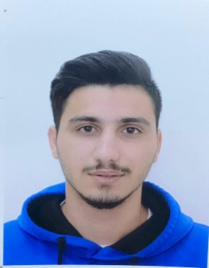Taimoor Mohammad Ali Ahmed Al Rashaydeh

20 years old – 10/10/1999

CPR 991006704

Flat 11 Road 2527 Building 858 Block 925

Number 33057017

E-mail: [Taimoor87.ali@gmail.com](mailto:Taimoor87.ali@gmail.com)

**Occupational Goal**

To expand my experiences to develop my skills, knowledge, and the ability to work hard.

**Education**

2014-2017 East Riffa Secondary Boys School.

Degree: Highschool (Scientific - Chemistry and Biology).

**Skills and Hobbies**

* Arabic: Good written and spoken.
* Little bit of English language spoken.
* Enjoy high degree of flexibility where I can work either individually or in a part of a team with great effectiveness and efficiency.
* Enjoy reading and writing.
* Capable of working extra hours.
* Time management skills.
* Have computer skills.

**Graduate Certificate**

Highschool Certificate.